Project Design Phase Solution Architecture

|  |  |
| --- | --- |
| Date | 23 March 2025 |
| Team ID | PNT2025TMID06665 |
| Project Name | **Predicting Plant Growth Stages with**  **Environmental and Management Data** |
| Maximum Marks | 4 Marks |

Solution Architecture:

Solution architecture defines the **end-to-end technical implementation** of the project, ensuring seamless integration between **data sources, processing, analytics, and user interaction**. This architecture helps in **analyzing environmental and management data** to predict **plant growth stages**, allowing farmers and agritech companies to optimize crop yield and sustainability.

**Example - Solution Architecture Diagram:**

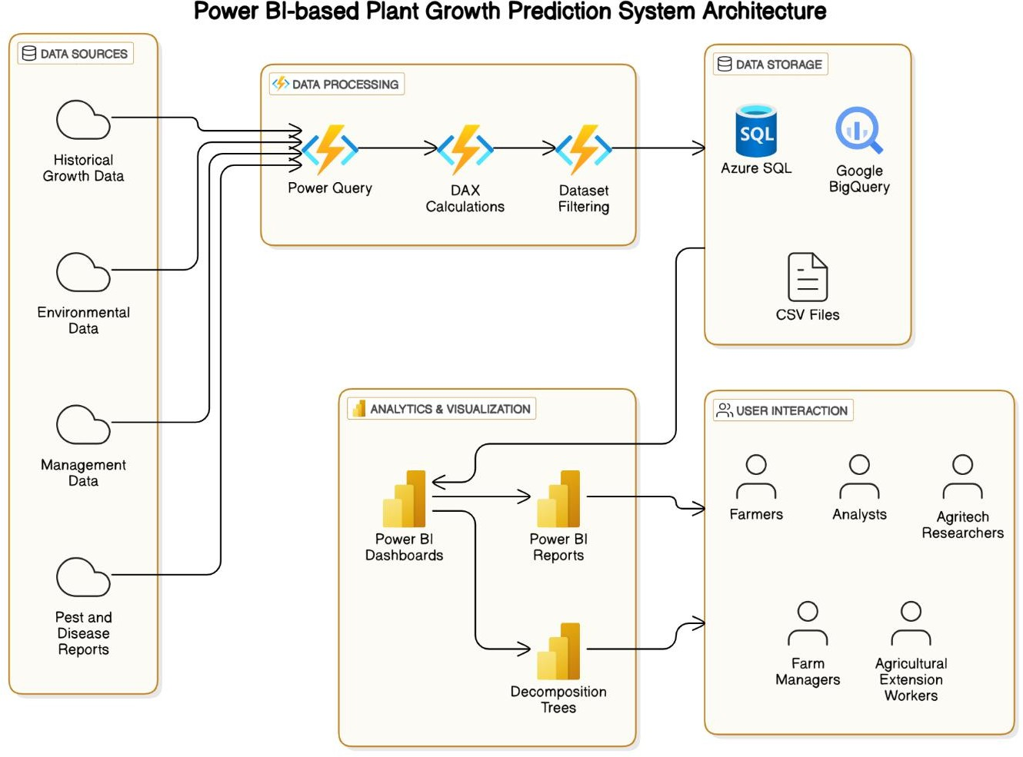

Figure 1: Architecture and data flow of the voice patient diary sample application